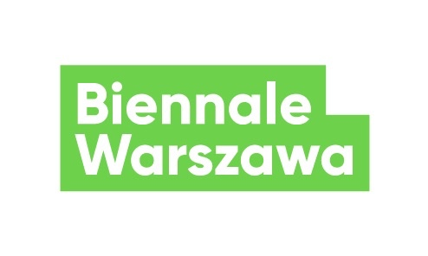
Press release, 25.03.2021
Call for the International Forum of Permaculture Educators
The call for the International Forum of Permaculture Educators, which will take place in Warsaw on 15 and 16 May, will be open until 5 April 2021 We encourage activists, and representatives of agro-ecological initiatives based in or cooperating with Warsaw to apply. Remuneration will be offered for active participation in the Forum.
International Forum of Permaculture Educators will be the first event of its kind organised in Poland. We want to provide an opportunity for development to individuals who are already active leaders of permaculture communities as well as those who only start out as educators. The objective of the forum is networking for people involved in permaculture education, who already know its premises and who work for food solidarity in Warsaw, in Masovia, and within initiatives working in this area, such as community gardens, food cooperatives, family garden allotments, CSAs, countrywomen's associations, daycares with gardens, educational homesteads, as well as farmers, gardeners working in permaculture, educators in natural building and permaculture pioneers. We will invite selected participants as well as foreign guests to discuss how to teach permaculture in the city, how to develop your workshop and how to increase social awareness and fully harness the potential of its premises.
On the first day, during a closed workshop session with selected participants, we will consider work methods and tools of permaculture educators. We will also try to ponder what could a roadmap look like for urban development and for the relationship between the city and the country in the coming years. The second day will take the form of a public forum, streamed online via organisers’ communication channels. Participants and invited guests will be asked to present a short talk. The entire event will conclude with a summarizing debate.
You can apply to participate in the Forum by completing our recruitment survey. The number of places is limited. Recruitment will begin on 5 April 2021, and before 12 April we will announce the list of selected participants. The Forum will be held in English. Biennale Warszawa does not cover costs of travel and accommodation of Forum participants in Warsaw. Persons selected in the recruitment process and invited to participate in the Forum will receive a remuneration of PLN 400 gross / PLN ... net (participants will sign with the organiser a contract for a specific work whose subject will be their active participation in the Forum and preparing and presenting a short talk.) One of our priorities is diversity among participants – it can determine the fact that a person from a less represented sector will be selected for the forum.
International Forum of Permaculture Educators is part of the project “Towards solidary nutrition. Warsaw 2030+,” carried out by Biennale Warszawa in cooperation with Agro-Perma-Lab Foundation, National Centre for Climate Change (KOKZ) and Nyéléni Polska network. The international partner of the Forum is European Cultural Foundation. The project also comprises a programme of meetings around the topic of food sovereignty and intergenerational workshops organised together with the Botanic Garden. The entire event will be summed up as a webdoc – a multimedia futuristic story about Warsaw that decided to support local food supply systems and initiatives facilitating the residents access to healthy, local food, where producers and consumers cooperate in solidarity to improve the resilience and well-being of the city. The project is curated by Anna Galas-Kosil. The project is financed by the Capital City of Warsaw.

Contact for the media:
Agnieszka Tiutiunik
agnieszka.tiutiunik@biennalewarszawa.pl
+48 730 390 601

