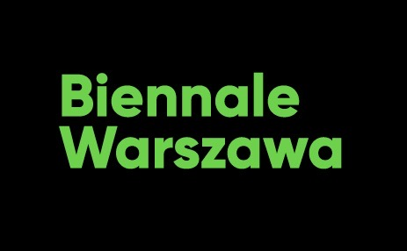

Press release, 18.10.2021
Biennale Warszawa 2022 — preparations begin
Today, technologies are the battlefield for our future. In them and through them the most important questions concerning our life and world will be decided. Today is it us – not the politicians and big tech companies – who should answer the question about which technologies we want in the future, and which we don’t want. This is why to these questions we will devote the second edition of our biennale which will be held in June and July 2022.
Via digital technologies we observe the most important contemporary phenomena: authoritarianism, capital flows, data expropriation, appropriation of our intimacy by technological companies, climate catastrophe and the politics of nature crisis, automation of almost every aspect of our lives, artificial intelligence or new fields of extraction of resources necessary for manufacturing digital devices. During Biennale Warszawa 2022, we will look at technologies with regard to algorithms which direct our lives, shape the rules of how society functions and ways we do politics. Equally important will be the reflection on new technological infrastructure of the world and digital ecology. To have agency in these areas, we should understand dynamic processes occurring in the field of technology and answer questions like:
How to create networks based on trust?
What is the relationship between artificial intelligence and politics? How about human psyche?
Can data from Google be used to precisely reconstruct a person’s life? And do we want tech corporations to use our weaknesses, disorders, addictions and the most intimate experiences to sell us products more effectively?
Is that true that across the world there are over 8.6 million data processing centres whose combined surface is 1.5 times larger than Paris, and that the #climatechange hashtag on Twitter is responsible for the emission of 70 kg CO2 annually?
Is blockchain a new chance for democratic cooperation and solidarity, or rather a libertarian nightmare?
Do algorithms fed with our data know us better than we know ourselves?
Do technologies today determine the limits of our freedom and define what we can or cannot do?
Just as important as works critical towards technologies and related phenomena will be journeys beyond the Silicon Valley and its limitations: creating and presenting technological prototypes, i.e. situations, social relationships, objects, organisations, inventions, ideas, processes or services that break the logic of extraction (resources, data) and exploitation of human work, and propose real alternatives for the status quo. To create them, we have invited artists, researchers, designers, scientists and activists, as well as polish and international institutions, organisations, and representatives of informal and formal initiatives.
Due to financial constrains following the pandemic, as well as restrictions of public activities, the second edition of biennale could not be held according to schedule in 2021. However, starting in the autumn of 2021, we focus our activities exclusively on preparations for Biennale Warszawa 2022. Our venue on Marszałkowska Street (MA3450) was refurbished as a meeting place and workshop space with studio visits, residencies and production of new works in mind.

Contact for the media:
Przemek Rydzewski
Media and communication
przemek.rydzewski@biennalewarszawa.pl
+48 502 064 567
Agnieszka Tiutiunik
Communications director
agnieszka.tiutiunik@biennalewarszawa.pl
+48 730 390 601

