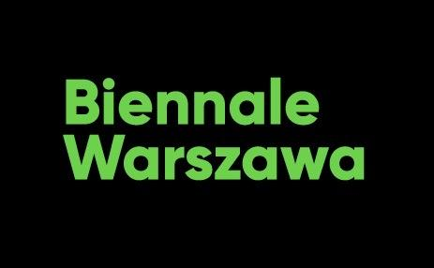

Press release, 20.04.2022

We know the date and place of the 2nd edition of Biennale Warszawa

The second edition of Biennale Warszawa entitled Seeing Stones and Spaces Beyond the Valley will be held at Wars Sawa Junior Department Stores in Warsaw, 104/122 Marszałkowska St. It will last from 3 June to 17 July, 2022.
The space opposite the Palace of Culture and the new Museum of Modern Art building under construction is the very center of the city, a place at the crossroads of communication routes connected with the new economy, trade and politics. This location of the exhibition provides an appropriate context for a conversation about the major challenges associated with the entanglement of technology, nature, politics, authoritarianism, and the new economy. It is to these themes that we dedicate Biennale Warszawa 2022.

Digital infrastructure and material objects of the Web, invisible and often overlooked in the conversation about technology; algorithms and artificial intelligence, considered by many to be neutral and objective, but in fact affecting all spheres of our lives; reactionary ideology and conservative politics hidden in the modern garb of technological development - these are, among others, the themes around which the works of nearly thirty artists from around the world, which will be shown at the main exhibition, are centered. It is accompanied by a public program that will include performative lectures, debates, workshops, presentations and seminars.
In the wake of the Russian aggression against Ukraine, works and speeches in which artists analyze authoritarian political practices made possible by new technologies assume special significance. These practices are based on mass surveillance of citizens. They use artificial intelligence and advanced data analytics for political, military and economic violence purposes and for cyberterrorism. The situation in Ukraine has led us to work with the artists, researchers, and scholars participating in the Biennale Warszawa 2022 to create new exhibition and public program elements that will allow us to adequately address these themes.
„We believe that technology is the lens through which all relevant geopolitical, political, social, economic, ecological, and cultural processes are seen, resulting in an increase in authoritarian tendencies in the world. By proposing a discussion on the role of technology, we actually open a debate on contemporary forms of authoritarianism and alternatives to them” – declare Anna Galas-Kosil, Bartosz Frąckowiak and Paweł Wodziński, curators of Biennale Warszawa 2022.
In the previous practice of Biennale Warszawa, critical reflection has always been complemented by actions aimed at designing or creating alternative solutions, ideas, or prototypes. The same is the case here. The exhibition will also feature works focused on designing more democratic, equal and just technologies. Their goal is to powerfully shape the future as we really want it. Today, more than ever, we need that freedom of imagination, lest we succumb to dystopian, fearful and paralyzing visions of catastrophe. Some of these works have been created by artists and activists fighting various forms of political and technological oppression in different parts of the world.
Seeing Stones and Spaces Beyond the Valley exhibition will be open Tuesday through Sunday from 12:00 p.m. to 8:00 p.m. Tickets on sale soon.

Organiser: Biennale Warszawa, Instytucja Kultury m.st. Warszawa
Curatorial team: Anna Galas-Kosil, Bartosz Frąckowiak, Paweł Wodziński
Concept of visual identity: Jakub de Barbaro; współpraca projektowa i produkcyjna: Marta Kowalska i Alina Lysachkova
Architectural design: CENTRALA (Simone De Iacobis, Małgorzata Kuciewicz)
Production: Ewa Kozik, Marta Michalak, Ela Petruk,
Public program coordination: Joanna Saran
PR and communication: Magdalena Jankowska, Przemek Rydzewski, Agnieszka Tiutiunik
Media Partners: „Przekrój”, „Tygodnik Powszechny”, „Szum”, „Notes na 6 Tygodni”, „Le Monde diplomatique”, Going, TOK FM

Contact for media:
Przemek Rydzewski
Media i komunikacja
przemek.rydzewski@biennalewarszawa.pl
+48 502 064 567

